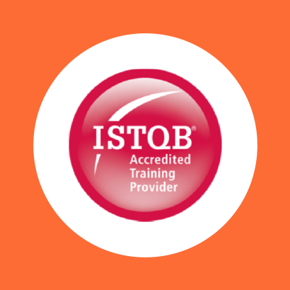

COURSE OUTLINE

Course Name: ISTQB Advanced Test Manager Module

|  |  |  |  |  |
| --- | --- | --- | --- | --- |
| **DURATION** | **SKILL LEVEL** | **DELIVERY**  **METHOD** | **TRAINING**  **CREDITS** | **TECHNOLOGY** |
| 5 Day(s) | Advanced | In Class/ VITL | N/A | ISTQB |

**Course Overview**

This five-day course focuses specifically on test management issues such as test estimation, monitoring and control, test documentation, selecting appropriate review types, introducing reviews into organisations, defect lifecycles, defect categorizations, process improvement, metrics, measures and people skills

**Prerequisite**

Candidates wishing to take the ISTQB Advanced Test Manager Certificate must hold the ISTQB FOUNDATION CERTIFICATE IN SOFTWARE TESTING.

**Audience**

This five day course is appropriate for test managers, test team leaders, development managers, project

managers and anyone wishing to gain the ISTQB Advanced Test Manager Qualification.

**Topics**

The course covers the following areas:

**BASIC ASPECTS OF SOFTWARE TESTING**

Builds upon those aspects introduced in the ISTQB Foundation Level Certificate. Explores the di-erent testing lifecycles, providing a detailed understanding of how to implement the most appropriate lifecycle. Explains specific systems, metrics and measures, allowing relevant testing strategies to be produced. TEST MANAGEMENT: TEST

**MANAGEMENT DOCUMENTATION**

Explains the di-erences between a test policy, test strategy, master test plan and level test plan. Examples of di-erent strategies are shown that could be used to meet defined policies.

**TEST PLAN DOCUMENTATION TEMPLATES**

Testing the system’s functionality is an important aspect for every tester, focusing on what the system does. Another vital area for every tester is to test the software’s characteristics – how well it behaves. Analysis of suitable techniques is provided to test the following characteristics for the test analyst: accuracy, suitability, interoperability, functional security, usability, and accessibility.

**TEST ESTIMATION**

Highlights the factors and considerations used when estimating testing. Discusses di-erent estimation techniques and how to e-ectively communicate this information to management

**SCHEDULING TEST PLANNING**

Explains the importance of test planning and highlights the benefit of iterative test planning.

**TEST PROGRESS MONITORING AND CONTROL**

We monitor testing to establish our project goals. Candidates will understand di-erent metrics that are necessary for collection and their significance when creating test reports.

**BUSINESS VALUE OF TESTING**

Testing needs to deliver value to any project and those benefits need to be understood by management. This session shows how testing can be measured in terms of value and efficiency.

**DISTRIBUTED, OUTSOURCED AND INSOURCED TESTING**

There is a need for clear channels of communication and trust, regardless of location. Test teams based across multiple locations encounter further challenges and these differences will be detailed in this section.

**FAILURE MODE AND EFFECT ANALYSIS (FMEA)**

FMEA is a very structured approach to understanding risk. Candidates will gain an understanding and experience of using this technique and assess the model’s use in their organisation.

**TEST MANAGEMENT ISSUES**

Identifies test management issues for the use and benefits of the Exploratory testing approach, as well as other issues such as non-functional testing.

**STANDARDS AND TEST IMPROVEMENT PROCESS**

Discusses different standards and improvement models and their usefulness. Presents various test improvement models such as Test Maturity Model (TMM), Systematic Test and Evaluation Process (STEP), Critical Testing Processes (CTP) and Test Process Improvement (TPI NEXT).

**PEOPLE SKILLS – TEAM COMPOSITION**

Provides understanding of individual tester skill sets and different ways to motivate test team members. Discusses contributing factors when identifying skills needed for an existing team and how test team dynamics can affect productivity. Presents different organizational structures for testing and the importance of independent test teams.

THE EXAM This course will provide the candidate with the necessary knowledge and skills to sit the ISTQB Advanced Test Manager Certificate multiple-choice exam. Candidates will be given the opportunity to sit the examination at the end of the course.

**Job Role**

**Exams and Certifications**

No associated Exams. A Certificate of completion is issued at the end of the Course.

**Notes and Annotations**

Not Any

Shape

**What is Next**

Art of communication